Chapter 12...
1. With this chapter we begin a fourteen-chapter study that focuses on the first Patriarch, Abram. What does the name Abram mean? Why was this a fitting name for him?
Abram means “Exalted Father.” It is a most appropriate name because he was exalted above others when God chose to speak to him and call him. He was also exalted with the promise that the Messiah would come through his lineage.

2. How was God’s call of Abram (vs. 1) a test of his faith?
God called him to leave his father and country to go to a land that he would later be shown. By removing himself from father and country Abram was leaving all of his natural support behind. On top of that, he didn’t know where he was going. Both aspects required faith/trust in God to provide for him and lead him.

3. There are seven elements to the promise God makes to Abram in verses 2-3. What are these elements and what is the significance of each?
1. “Make you a great nation” – This promise establishes the Hebrew nation through which the Messiah would come and God would work His deliverance. This also took faith to accept since Sarai was barren.
2. “I will bless you” – To bless is to place in a prominent position. Abram would have God’s told attention and God would provide Abram and Sarai all they needed.
3. “Make your name great” – This is a promise of great honor. People would always remember Abram.
4. “So that you will be a blessing” – The word so ties this element to the first three. God would do all this so that Abram could do the same for others. This was actually a command. Abram fulfilled this whenever he shared the truth of the living God or put others first.
5. “Bless those who bless you” – It is interesting to note that the word those is plural. Those peoples who show kindness to Abram would be shown kindness by God.
6. “Him who dishonors you I will curse.” – Any individual who opposed Abram would find himself cursed by God.
7. “In you all the families of the earth shall be blessed.” – This is a reference to the Messiah who would come to bring salvation to all who believe.

4. Who accompanied Abram on this journey?
Abram took his wife Sarai, his nephew Lot and all of their servants when they had acquired. We do know he had brought some male servants (17:12).

5. How old was Abram when he started this journey?
Abram was 75 years old.

6. Who were the Canaanites? (10:6-19)
The Canaanites were the descendants of Ham’s son Canaan.

7. Where did Abram first stop when he arrived in Canaan? What did the Lord tell him? How did Abram respond?
Abram first stopped at the oak of Moreh by Shechem. The Lord promised to give him the land. Abram responded by making an altar to the Lord there.

8. Where was Abram’s next encampment? What do we know that he did there?
Abram next stopped in the hill country between Bethel and Ai. There, he: 1) Pitched his tent
2) Built an altar to the Lord
3) Called upon the name of the Lord

9. What does it mean to call upon the name of the Lord?
This is not a private prayer but a public proclamation. The Hebrew verb literally means “to proclaim” or “to preach.”

10. Verse nine tells us that “Abram journeyed on, still going toward the Negeb.” What is the Negeb?
The Hebrew word translated as Negeb or Negev means south. Abram was traveling towards the south.

11. Why did Abram continue in this direction? Where did he finally stop?
There was a famine or drought in the land so Abram continued going south until he came to Egypt. With the Nile River having such a large watershed, Egypt was almost immune to the effects of a drought.

12. What was Abram’s concern in this new land? Why?
Abram feared for his life because he knew that Sarai, his wife, was beautiful. He could not simply slip into the land because his entourage was too large. Therefore, his entrance would get the attention of the Egyptians, they would see Sarai’s beauty, and they might kill Abram to take her.

13. This is really quite a remarkable section of the Bible. Rarely does the Bible focus on a person’s appearance. Now consider this: What was Abram’s age at this time? (12:45) 75
Using 17:17 as a guide. What was Sarai’s age at this time? 65
To be praised to Pharaoh for her beauty at this age is remarkable.

14. What was Abram’s solution to the problem?
Instead of trusting God he told Sarai to say that she was his sister.

15. This solution has been the topic of much discussion and a sermon or two. Before we judge Abram and his plan, read Genesis 20:12. What do we learn from this verse?
Genesis 20:12 tells us that Sarai was actually Abraham’s half-sister. They had the same father but different mothers.

16. Did Abram lie? Was this a sin? How can we label his action? (Jeremiah 17:9)
Abram did not lie but he also did not tell the whole truth. This is deception and is consistent with Jeremiah’s description of man’s heart; it is deceitful. Therefore, Abram’s action was sinful because:
- He trusted his deceitful scheme instead of God.
- He was not totally honest.

17. How did the Egyptians react to Abram’s story?
Pharaoh took Sarai as his wife & paid Abram a healthy dowry for her.

18. How did God react to Pharaoh’s actions? (vs. 17)
God brought plagues on Pharaoh’s house because he had taken Sarai.

19. Compare verse 13 to verse 17. Why did Abram claim Sarai as his sister? (vs. 13)
To save his life.

20. Why did God take his action? (vs. 17)
God intervened because of Sarai or on her behalf.

21. How did Pharaoh react to all of this? Why?
Pharaoh gave Sarai back to Abram and sent them out of the country with all that they had. Pharaoh realized what he had done was wrong. His dowry payment became a peace offering.

Chapter 13...
22. Following the whole Egypt debacle, where did Abram go? Why?
Abram went back to the place where he had pitched his tent and built an altar between Bethel and Ai. He probably went there because this was where God had appeared to him.

23. What was the first thing Abram did in this place?
Again, Abram called on the Name of the Lord or proclaimed God to the people.

24. What problem did Abram encounter when he tried to settle in this region?
The land was not able to support both his and Lot’s herds.

25. What was Abram’s solution to this problem?
Abram noted a need to split up because of the inability of the land to support both herds. He offered Lot the first choice of where he wanted to live.

26. What is noteworthy about Abram’s solution? (Note: Consider both the Egypt situation of Chapter 12 as well as the relationship between Abram and Lot)
In Egypt, Abram acted out of self-centered fear and desire to save himself. He did not take into account Sarai’s feelings or well-being. He acted very patriarchal. In chapter 13, he now puts Lot’s well-being ahead of his own and does not exercise any of his patriarchal rights as Lot’s elder or uncle. There has been a dramatic change in Abram.

27. What land did Lot choose? Why?
Lot chose the Jordan River valley because it was very fertile. In fact, it was compared to the Garden Eden. This was obviously the better land to raise livestock in.

28. Verse 12 gives us a little more information about Lot’s choice. Carefully read this verse. Where did Lot settle? What was required for him to settle there?
Lot settled among the cities of the Jordan River Valley. The key word in this verse is “far.” Since he moved his tent as far as Sodom it indicates he had to travel quite a distance to get there. For this reason, it is thought that Sodom was located somewhere in the region of what is now the Dead Sea.

29. What do we learn about Sodom?
The men of Sodom were wicked and great sinners against the Lord.

30. Why is this notation about Sodom in this place significant?
The men of Sodom were identified as evil prior to Lot living there. Some people claim that the reason God destroyed Sodom was because the men were not hospitable. They claim this evidenced by their unwelcoming spirit toward the Lord’s angels in Genesis 19. However, they must have been hospitable since Lot went from living in a tent in the vicinity to living in a house within the city limits.

31. Abram was left with the less fertile hill country. Yet, what does God tell Abram?
Vss. 14-15 – God told Abram to look in every direction and promised him all the land he could see.
Vs. 16 – God promised Abram that his offspring would be so large that no could count it.
Vs. 17 – God told him to walk the land, it was his.

32. Where did Abram end up settling? Why? (Consider the implication of verse 12)
Abram ended up settling in the hills of Hebron. This was probably due west of Sodom where Lot was living. Abram was looking after his nephew.

33. What did Abram do once he moved his tent to the region?
Abram built an altar to the Lord.

Life Challenge: Notice what Abram did at each stage of the Chapter 12-13 narrative. With the exception of his self-centered time in Egypt, he always put the Lord first and built an altar to worship God with. Look at your own life. Are you building altars to the Lord? To someone else? Or not at all?
“So, whether you eat or drink, or whatever you do, do all to the glory of God.” (1st Corinthians 10:31)

__________________________________________________________________________________________________________________________________________________________________________________________________________________________________________________________________________________________________________________________________________

Abram’s Journey in Canan

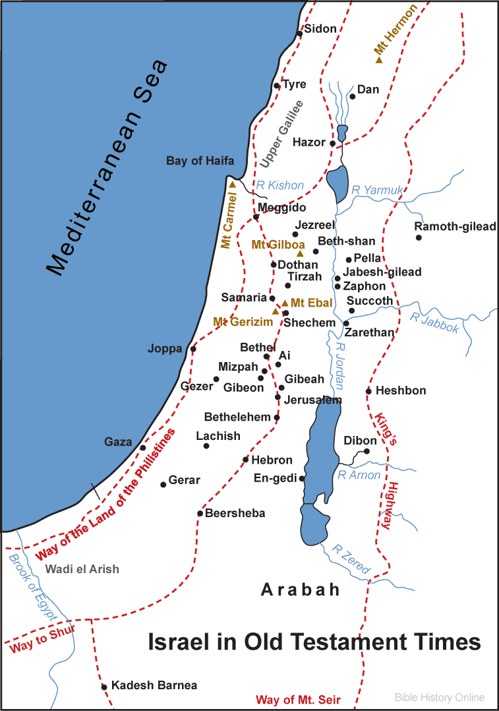

Abram first stopped at Shechem (12:6). Next he went to the hill country between Bethel and Ai (12:8). From there he went to Egypt because of a famine in the land. He returned to the region between Bethel and Ai (13:3) and then settled in the region of Hebron (13:18). SDG-Lesson #9-Genesis
Abram first stopped at Shechem (12:6). Next he went to the hill country between Bethel and Ai (12:8). From there he went to Egypt because of a famine in the land. He returned to the region between Bethel and Ai (13:3) and then settled in the region of Hebron (13:18). SDG – Lesson #9 - Genesis

